# Modified NEB ultra II protocol for small DNA fragments

Choose your protocol:



For Henikoff lab protocol, please see their Nature Protocol paper.

Why?

The difference between NEB stem loop adapters and illumina adapters are their lengths. When ligated to both ends of DNA, they add 64bp and 124bp respectively. This makes huge difference when you do beads based cleaning up.

What is this protocol?

This protocol is based on library preparation manual of “NEBNext® Ultra™ II DNA Library Prep Kit for Illumina”, NEB E7645, and is specifically modified to make libraries from small DNA fragments (30-70bp). We have successfully used it in our recent work and showed that it greatly increased the preservation of small fragments (Liu, Cell 2018. Fig. S2B [[pdf](http://the_brain.bwh.harvard.edu/pubs/Liu_Cell2018_BCL11A_Epub.pdf)])

Any change from original NEB protocol is in blue, and critical changes are in underlined blue. Critical changes are essential to save small DNA fragments.

If you have any questions or suggestions, please leave your comment or email me at [nan.liu@enders.tch.harvard.edu](mailto:nan.liu@enders.tch.harvard.edu)

Last update: 12/11/2018

# 1. NEBNext End Prep

1.1. Add the following components to a sterile nuclease-free tube:

|  |  |
| --- | --- |
| • (green) NEBNext Ultra II End Prep Enzyme Mix | 1.5 μl |
| • (green) NEBNext Ultra II End Prep Reaction Buffer | 3.5 μl |
| Fragmented DNA (6 ng) | 25 μl |
| Total volume | 30 μl |

Scaling down is not essential for the protocol to work. But if you use the original volume (60 μl reaction), the volume will exceed the PCR tube in step 3.2.

The largest amount of DNA I used is 30 ng. I don’t recommend using more DNA since dA-tailing reaction in step 1.3 is adjusted to a suboptimal temperature. More DNA may not be efficiently dA-tailed.

1.2. Set a 100 μl or 200 μl pipette to 20 μl and then pipette the entire volume up and down at least 10 times to mix thoroughly. Perform a quick spin to collect all liquid from the sides of the tube.

*Note: It is important to mix well. The presence of a small amount of bubbles will not interfere with performance.*

1.3. Place in a thermocycler, with the heated lid set to ≥ 60°C, and run the following program:

30 minutes @ 20°C

60 minutes @ 50°C

Hold at 4°C

Decreasing temperature to 50°C can significantly help saving very small fragments (25-40 bp) as seen in our sequencing data.

*If necessary, samples can be stored at –20°C; however, a slight loss in yield (~20%) may be observed. We recommend continuing with adaptor ligation before stopping.*

# 2. Adaptor Ligation

2.1. Determine whether adaptor dilution is necessary.

Use 10X to 20X molar amount of adapter. For example, 6 ng DNA with an average size of 50 bp is about 0.2 pmol. I use 4 pmol adapter.

Update: It is possible to reduce the amount of adapters to 3-5X, which can significantly reduce the amount of final PCR dimers.

2.2. Add the following components directly to the End Prep Reaction Mixture:

|  |  |
| --- | --- |
| End Prep Reaction Mixture (Step 1.3) | 30 μl |
| • (red) NEBNext Ultra II Ligation Master Mix | 15 μl |
| • (red) NEBNext Ligation Enhancer | 0.5 μl |
| • (red) NEBNext Adaptor for Illumina | 1.25 μl |
| Total volume | 46.75 μl |

*Note: The Ligation Master Mix and Ligation Enhancer can be mixed ahead of time and is stable for at least 8 hours @ 4°C. We do not recommend adding adaptor to a premix in the Adaptor Ligation Step.*

2.3. Set a 100 μl or 200 μl pipette to 40 μl and then pipette the entire volume up and down at least 10 times to mix thoroughly. Perform a quick spin to collect all liquid from the sides of the tube. (Caution: The NEBNext Ultra II Ligation Master Mix is very viscous. Care should be taken to ensure adequate mixing of the ligation reaction, as incomplete mixing will result in reduced ligation efficiency. The presence of a small amount of bubbles will not interfere with performance).

2.4. Incubate at 20°C for 15 minutes in a thermocycler with the heated lid off.

2.5. Add 1.5 μl of • (red) USER™ Enzyme to the ligation mixture from Step 2.3.

*Note: Steps 2.5 and 2.6 are only required for use with NEBNext Adaptors. USER enzyme can be found in the NEBNext Singleplex (NEB #E7350) or Multiplex (NEB #E7335, #E7500, #E7710, #E7730, #E7600 and #E6609) Oligos for Illumina.*

2.6. Mix well and incubate at 37°C for 15 minutes with the heated lid set to ≥ 47°C.

Samples can be stored overnight at –20°C.

# 3. Size Selection or Cleanup of Adaptor-ligated DNA

3.1 Size Selection of Adaptor-ligated DNA

Don’t do size selection.

3.2 Cleanup of Adaptor-ligated DNA without Size Selection

3.2.1. Vortex SPRIselect Beads to resuspend (AMPure XP Beads can be used as well). If using AMPure XP Beads, allow the beads to warm to room temperature for at least 30 minutes before use.

3.2.2. Add ~~100 μl (2.1X)~~ 80 μl resuspended SPRIselect beads to the Adaptor Ligation reaction. Mix well by pipetting up and down at least 10 times. Be careful to expel all of the liquid out of the tip during the last mix. Vortexing for 3-5 seconds on high can also be used. If centrifuging samples after mixing, be sure to stop the centrifugation before the beads start to settle out.

Using of ~~100 μl (2.1X)~~ 80 μl AMPure XP beads is essential to purify ligated products. It is possible to further increase the amount, but be careful of adapter carry over.

3.2.3. Incubate samples on bench top for at least 5 minutes at room temperature.

3.2.4. Place the tube/plate on an appropriate magnetic stand to separate the beads from the supernatant. If necessary, quickly spin the sample to collect the liquid from the sides of the tube or plate wells before placing on the magnetic stand.

3.2.5. After 5 minutes (or when the solution is clear), carefully remove and discard the supernatant. Be careful not to disturb the beads that contain DNA targets (Caution: do not discard the beads).

3.2.6. Add 200 μl of 80% freshly prepared ethanol to the tube/ plate while in the magnetic stand. Incubate at room temperature for 30 seconds, and then carefully remove and discard the supernatant. Be careful not to disturb the beads that contain DNA targets.

3.2.7. Repeat Step 3.2.6 once for a total of two washes. Be sure to remove all visible liquid after the second wash. If necessary, briefly spin the tube/plate, place back on the magnet and remove traces of ethanol with a p10 pipette tip.

3.2.8. Air dry the beads for up to 5 minutes while the tube/plate is on the magnetic stand with the lid open.

Caution: Do not over-dry the beads. This may result in lower recovery of DNA target. Elute the samples when the beads are still dark brown and glossy looking, but when all visible liquid has evaporated. When the beads turn lighter brown and start to crack they are too dry.

3.2.9. Remove the tube/plate from the magnetic stand. Elute the DNA target from the beads by adding 15 μl of 10 mM Tris-HCl or 0.1X TE.

3.2.10. Mix well by pipetting up and down 10 times, or on a vortex mixer. Incubate for at least 2 minutes at room temperature. If necessary, quickly spin the sample to collect the liquid from the sides of the tube or plate wells before placing back on the magnetic stand.

3.2.11. Place the tube/plate on the magnetic stand. After 5 minutes (or when the solution is clear), transfer 13 μl to a new PCR tube.

Samples can be stored at –20°C.

# 4. PCR Enrichment of Adaptor-ligated DNA

4.1 PCR Amplification

4.1.1. Add the following components to a sterile strip tube:

|  |  |
| --- | --- |
| Adaptor Ligated DNA Fragments (Step 3.2.11) | 13 μl |
| • (blue) NEBNext Ultra II Q5 Master Mix | 15 μl |
| • (blue) Index Primer/i7 Primer | 1 μl |
| • (blue) Universal PCR Primer/i5 Primer | 1 μl |
| Total volume | 30 μl |

The amount of primers here is enough to generate sufficient PCR product. PCR volume is scaled down only to help using the reagents in one kit with similar speed. Alternatively, you can use the original PCR setup and order separate Q5 mix from NEB (M0544S).

4.1.2. Set a 100 μl or 200 μl pipette to 30 μl and then pipette the entire volume up and down at least 10 times to mix thoroughly. Perform a quick spin to collect all liquid from the sides of the tube.

4.1.3. Place the tube on a thermocycler and perform PCR amplification using the following PCR cycling conditions:

|  |  |  |  |
| --- | --- | --- | --- |
| Initial Denaturation | 98°C | 30 seconds | 1 |
| Denaturation | 98°C | 10 seconds | 12 |
| Annealing/Extension | 65°C | 10 seconds |
| Final Extension | 65°C | 5 minutes | 1 |
| Hold | 4°C | ∞ |  |

When starting with 6 ng DNA, I’ve obtained 10-40 ng of DNA with 12 cycles of amplification with different samples.

4.1.4. Proceed to Cleanup of PCR Amplification in Section 5.

# 5. Cleanup of PCR Reaction

5.1. Vortex SPRIselect beads to resuspend. AMPure XP beads can be used as well. If using AMPure XP beads, allow the beads to warm to room temperature for at least 30 minutes before use.

5.2. Option A: Add 36 μl (1.2X) resuspended SPRIselect beads to the PCR reaction. Mix well by pipetting up and down at least 10 times. Be careful to expel all of the liquid out of the tip during the last mix. Vortexing for 3-5 seconds on high can also be used. If centrifuging samples after mixing, be sure to stop the centrifugation before the beads start to settle out.

To precipitate the smallest library DNA molecules (25bp + 128bp adapter = 153 bp), 1.2X beads is recommended.

5.2. Option B: Bring up the reaction to 70μl by adding 40 μl ddH2O. Do a double size selection by adding 63 μl (0.9X), then 21μl (1.2X final) to supernatant.

Option B enriches library size from 150-250bp, corresponding to fragment size 28-128 bp. So you lose all >140 bp information. In CUT&RUN eLife paper, >140 bp fragments can reflect the nucleosome information surrounding the TF. Make your choice based on your interest. Important: this option removes spike-in DNA. If you use spike-in DNA, please do not use this option.

5.3. Incubate samples on bench top for at least 5 minutes at room temperature.

5.4. Place the tube/plate on an appropriate magnetic stand to separate the beads from the supernatant. If necessary, quickly spin the sample to collect the liquid from the sides of the tube or plate wells before placing on the magnetic stand.

5.5. After 5 minutes (or when the solution is clear), carefully remove and discard the supernatant. Be careful not to disturb the beads that contain DNA targets (Caution: do not discard the beads).

5.6. Add 200 μl of 80% freshly prepared ethanol to the tube/ plate while in the magnetic stand. Incubate at room temperature for 30 seconds, and then carefully remove and discard the supernatant. Be careful not to disturb the beads that contain DNA targets.

5.7. Repeat Step 5.6 once for a total of two washes. Be sure to remove all visible liquid after the second wash. If necessary, briefly spin the tube/plate, place back on the magnet and remove traces of ethanol with a p10 pipette tip.

5.8. Air dry the beads for up to 5 minutes while the tube/plate is on the magnetic stand with the lid open.

Caution: Do not over-dry the beads. This may result in lower recovery of DNA target. Elute the samples when the beads are still dark brown and glossy looking, but when all visible liquid has evaporated. When the beads turn lighter brown and start to crack they are too dry.

5.9. Remove the tube/plate from the magnetic stand. Elute the DNA target from the beads by adding 33 μl of 0.1X TE.

5.10. Mix well by pipetting up and down 10 times, or on a vortex mixer. Incubate for at least 2 minutes at room temperature. If necessary, quickly spin the sample to collect the liquid from the sides of the tube or plate wells before placing back on the magnetic stand.

5.11. Place the tube/plate on the magnetic stand. After 5 minutes (or when the solution is clear), transfer 30 μl to a new PCR tube for and store at –20°C.

5.12. Check the size distribution on an Agilent Bioanalyzer High Sensitivity DNA chip. The sample may need to be diluted before loading. Please see supplemental figures below for examples of library size distribution.

Since the size of library is so near to the PCR dimer (128 bp), sometimes there are residual dimers. The ratio of dimers is mostly 1-20% in my experiments. You can easily get rid of them by doing another round of 1.2X AMPure XP beads clean up.

If you get too many dimer contamination, you can do 1.1X AMPure XP beads clean up, but you will also lose some library DNA. In this case, I recommend doing gel based size selection, using a 2-3% agarose gel. Pippin Prep is a good option to do gel based size selection.

# Sequencing and data processing tips:

1. Be sure to do pair end sequencing.
2. Be aware that there will be several bases of adapter sequences in some of the reads. For example, I sequence 42 bp each read. So for all fragments that are shorter than 42bp, there will be adapter sequences at 3’ of the reads. You need to trim them. My collaborator Qian Zhu has developed an easy to use pipeline for CUT&RUN data processing [here](https://bitbucket.org/qzhudfci/cutruntools/src). Please contact me or Qian with any questions. Some details can be found in the method section in our 2018 [paper](http://the_brain.bwh.harvard.edu/pubs/Liu_Cell2018_BCL11A_Epub.pdf).

Tapestation of final library, examples (double size selection after PCR)

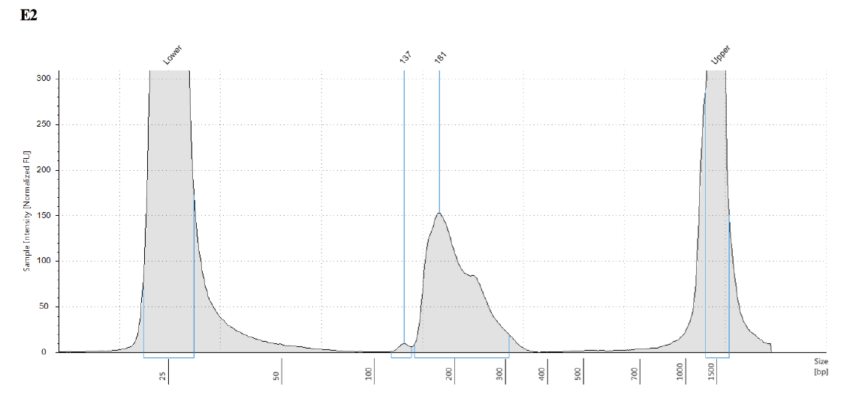

1.2X AMPure purification can completely remove all dimers in this sample↑.

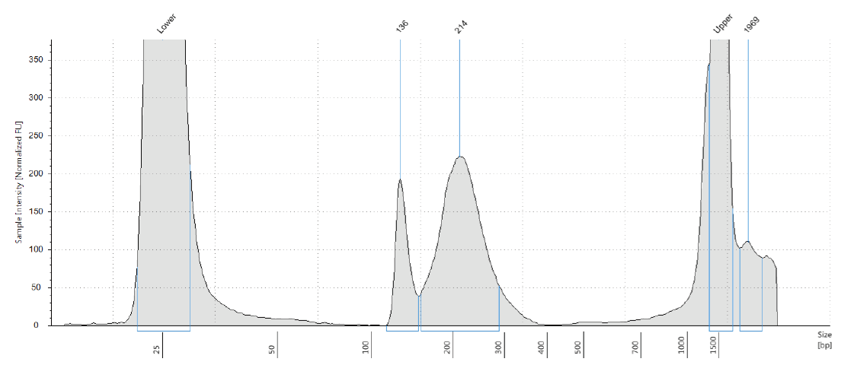

This one need gel based purification to remove dimers.